*Clear Liquid Diet Details: NO RED or PURPLE, ORANGE
Approved | Avoid
Sodas, coffee, tea, lemonade | No milk/dairy
Clear juices, fitness waters | No juices with pulp
Popsicles without pulp | NO RED, PURPLE, ORANGE
Chicken, vegetable and beef broth
Gelatin
7 days to procedure | Review your prep instructions thoroughly. Review medication changes/restrictions starting today.  Stop Anti-Inflammatory meds (Advil, Ibuprofen, Aleve, etc.), Vitamins, & Iron unless directed by your physician.
5 days to procedure |   STOP eating any raw vegetables or vegetables containing seeds, corn, popcorn, nuts, and seeds and stop any fiber supplements until after the procedure.  Purchase clear liquid diet items, ointment, reading material, etc.
2 Days to procedure |   Continue a low fiber diet. Remember to avoid foods with nuts and seeds.  Confirm arrangements with your driver.
1 day to procedure | NO SOLID FOODS, CLEAR LIQUIDS* ONLY upon rising, until after your procedure.  Prep at a Glance  6:00 PM- Drink prep solution and take 2 tablets.  11:00 PM- Drink prep solution and take 2 tablets.  Drink plenty of water and liquids throughout the day to avoid dehydration. Do not eat or drink anything after midnight the evening before your procedure.  Detailed, step-by-step instructions continue on page 2.
Procedure Day | Nothing to drink. No solid food. NO Diabetic Meds. No smoking.  No Gum or hard candy | you MAY brush your teeth but DO NOT swallow  *If you take daily medication, you may take it with SMALL SIPS OF WATER ONLY, at least 2 hours before your procedure.
The following instructions are your physician’s specific instructions. Please follow the instructions carefully to ensure a successful prep.
You can reach Your Patient Advisor with non-medical prep questions at: 800.349.0285
If you need to reach your physician’s office, please call 732-873-9200.
Special Notes: SOMEONE MUST DRIVE YOU HOME FROM THE FACILITY THE DAY OF YOUR PROCEDURE. You must be accompanied by an adult friend, relative or caregiver to drive you home. You may not drive home or go by taxi or bus. If you do not have a driver, your procedure will be cancelled. You should plan to be at the surgery center 2-3 hours.

PREP WEEK AT A GLANCE
Prep Day: The Day Prior To Your Procedure
Drink plenty of water throughout the day to avoid dehydration.
Step  1 |  | The day prior to your procedure  Mix 1 packet of drink mix powder/Gatorade with 32 oz of water and chill in the refrigerator. | 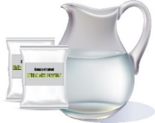
Step  2 |  | 5:00 PM- The day prior to your procedure  Mix together HALF of the BOTTLE (8.3oz/238g) of Polyethylene Glycol 3350 with 32 oz. of chilled drink mix. | 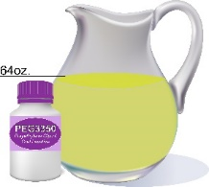
Step  3 |  | 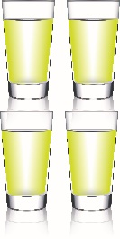  6:00 PM- The day prior to your procedure  Drink solution, 8 oz every 15 minutes until gone.  Take (2) 5mg Bisacodyl/Dulcolax tablets | 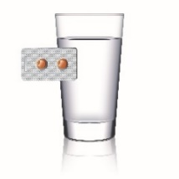
Individual responses to laxatives vary.
This preparation will cause multiple bowel movements, stay close to a bathroom.

Step  4 |  | 11:00 PM- The day prior to your procedure  Mix 1 packet of drink mix powder/Gatorade with 32 oz of water and chill in the refrigerator. | 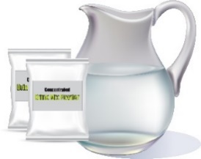  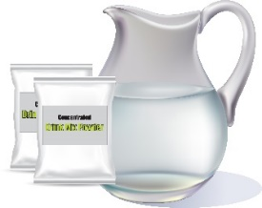
Step  5 |  | 30 minutes before drinking the Polyethylene Glycol solution-  Mix together the remaining half BOTTLE (8.3oz/238g) of Polyethylene Glycol 3350 with 32 oz. of chilled drink mix. | 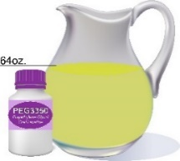
Step  6 |  | 11:00 PM The day prior to your procedure  Drink 8 oz of the Polyethylene Glycol solution every 15 minutes until the solution is completely gone. Complete drinking the solution by midnight.  Take 2 (5mg) Bisacodyl (Dulcolax) tablets. | 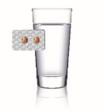  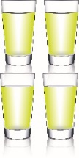  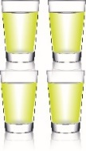

Day of Procedure Information
- Wear your glasses, if you don’t have glasses, bring contact lens case and solution with you. Contacts must be removed prior to procedure.
- Have a responsible adult driver.
- Bring your picture ID, insurance cards, co-pay, or deductible portion of your procedure.
- Bring your inhaler.
- Bring your medication list.
- Please do not wear any cologne, perfume, aftershave or body lotion.
- Please do not wear any jewelry.
- You may shower and apply deodorant before arriving for the procedure.
You do not need to come in earlier than your stated arrival time. Additional time for check-in and admission is already built into the arrival time.
5 Days Prior to Procedure Diet
Low Residue/Low Fiber Diet
Allowed
White bread or rolls without nuts and seeds | Plain white pasta, noodles, rice noodles, macaroni
Crackers, potato chips | Refined cereals such as Cream of Wheat, Cheerios, Rice Krispies
Pancakes or waffles | Fruit and vegetable juice with little/no pulp
Lean meat, poultry, fish, sausage, bacon | Eggs, tofu, creamy peanut butter
Milk & foods made from milk (yogurt-without fruit) | Pudding, ice cream, cheeses, cottage cheese, sour cream
Butter, margarine, oils, and salad dressing without seeds or nuts | Cheese pizza, spaghetti with no veggie chunks
Applesauce or pear sauce | Potatoes-instant or white varieties with no skin
Desserts with no whole grains, seeds, nuts, raisins, or coconut | Apricots (peeled)
Asparagus tips (well cooked) | Cantaloupe, honeydew, melon, and papaya (ripe)
Carrots (peeled & cooked until soft) | Bananas
Peaches (ripe and peeled) | Mushrooms (well cooked)

Foods to Avoid
Whole wheat/whole grain breads, cereals, and pasta | Whole grains (oats, kasha, barley, quinoa)
Beans, peas & lentils | Seeds, nuts, popcorn
Brown & wild rice | Fruits & vegetables high in fiber or containing seeds or skins
Tough fibrous meats with gristle, raw clams, and oysters | Coconut
If you have any questions or concerns about the preparation, please contact Your Patient Advisor by calling 800-349-0285 or emailing support@yourpatientadvisor.com.

Bowel Prep Frequently Asked Questions
What is a clear stool?
A clear stool can have a slight tint of yellow or brown. It will be completely transparent, and will not contain any solid matter.

I am not having bowel movements, what should I do?
Bowel movements can take up to 5-6 hours after beginning the prep to start. Be patient, continue to drink liquids. If you have not had a bowel movement by midnight the night prior to your procedure, you will need to reach the on call physician for further instructions.

The prep is making me nauseous, what should I do?
If you develop nausea or vomiting, slow down the rate at which you drink the solution. Please attempt to drink all of the laxative solution even if it takes you longer. If vomiting persists, or you are not able to finish the preparation, stop the preparation and call your physician’s office for further instructions.

What are some high fiber foods I should avoid?
Raw fruits and vegetables are typically high in fiber, as well as nuts, seeds, whole grain breads and beans and lentils.

What are some good options for low fiber foods?
Choose white bread and white rice for lower fiber options, as well as pastas made with white flour. Chicken, fish, dairy and eggs are also low in fiber and good choices for foods 2-3 days before you begin your prep.

If I eat popcorn or seeds 3 days before my procedure do I need to reschedule?
You will not need to reschedule your procedure, however the seeds or nuts may cause a difficulty in screening and require a need for rescreening. If you have eaten a large amount of seeds or nuts, you may want to contact the nurse or physician.

Can I drink ALCOHOL on the liquid diet?
Alcohol is not allowed as part of the liquid diet.

Can I continue to be on the liquid diet after I begin consuming the laxatives?
Yes, you may continue the liquid diet until you are directed to discontinue anything by mouth, which is typically 4-6 hours prior to the procedure.
Why do I have to wake up so early for the 2nd dose, can’t I take it all the night before?
A split prep has proven to be the most effective for a successful colonoscopy. It is essential that you follow the directions provided with your prep medications.
If I weigh under 100 pounds do I need to take all of the prep?
The liquid amount is not weight dependent. It is important to finish the prep for a successful colonoscopy.

